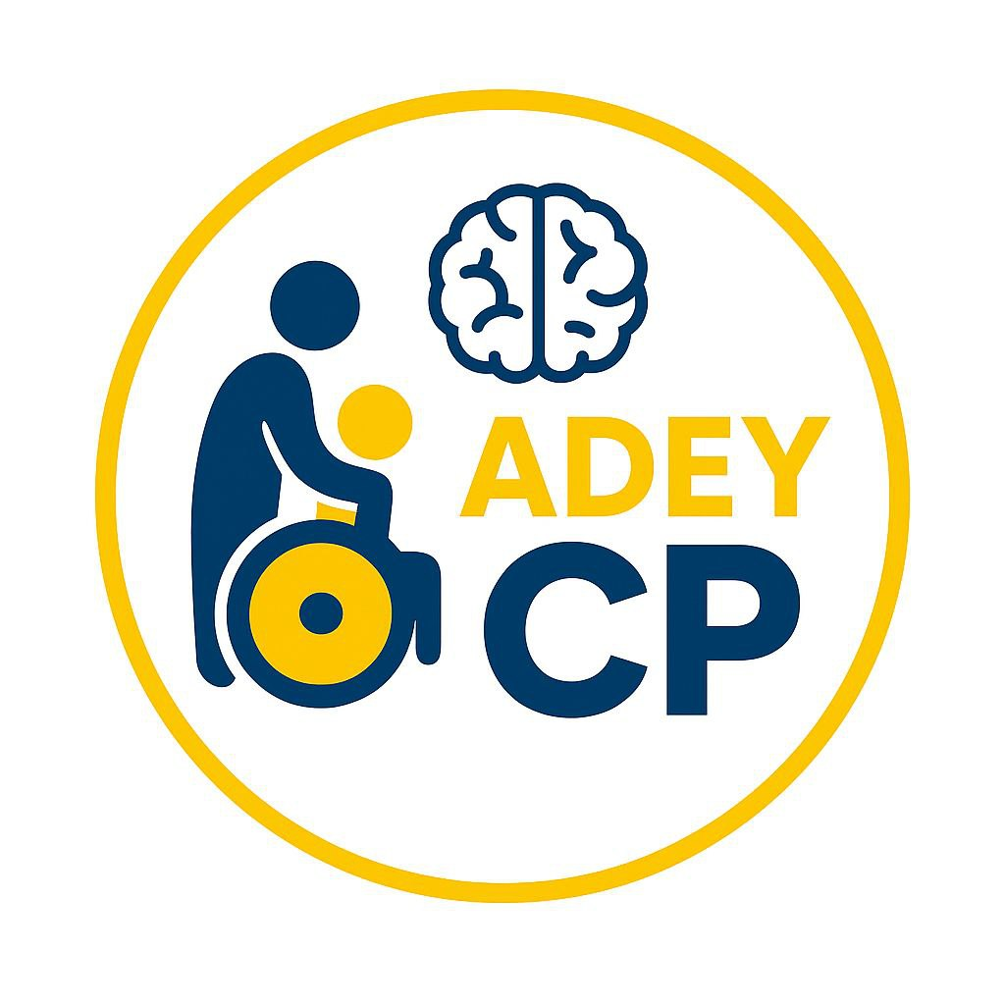Adey Cerebral Palsy Organization Profile
Established: August 2024
Licensed by: Authority for Civil Society Organizations (ACSO), Ethiopia
Address: Addis Ababa, Ethiopia, Lemi Kura Sub city
Phone: +251-911-436965
Email: adeycp@gmail.com

1. About Us
Adey Cerebral Palsy Organization (ACPO) is a non-profit organization dedicated to supporting children with Cerebral Palsy (CP) and their families in Ethiopia. We focus on awareness, early intervention, healthcare access, inclusive education, and advocacy to improve the quality of life for individuals affected by CP.
Our organization was founded by five dedicated individuals, with 16 General Assembly Members and a 5-member Board of Directors, committed to making a lasting impact on CP awareness and care in Ethiopia.

2. Vision, Mission & Goals
Vision
To create an inclusive society where children with cerebral palsy in Ethiopia receive the care, education, and opportunities they deserve, enabling them to live dignified and fulfilling lives.
Mission
- To raise awareness about Cerebral Palsy (CP) in Ethiopian communities.
- To improve healthcare access and provide early detection & intervention for children with CP.
- To empower families and caregivers with training, resources, and economic opportunities.
- To promote inclusive education, advocacy, and research on CP in Ethiopia.
- To collaborate with government, NGOs, and international partners for sustainable support.
Core Values
✅ Inclusivity
✅ Empowerment
✅ Advocacy
✅ Sustainability
✅ Collaboration

3. Objectives & Focus Areas
- Awareness Raising:
- Conduct nationwide campaigns, workshops, and media programs to educate communities about CP.
- Reduce stigma and promote acceptance of children with disabilities.
- Early Detection & Intervention:
- Train healthcare workers & midwives for early CP diagnosis.
- Provide early therapy and rehabilitation services.
- Access to Healthcare Services:
- Improve access to physical therapy, occupational therapy, and assistive devices.
- Support families in navigating healthcare options.
- Capacity Building:
- Train teachers, therapists, and caregivers to provide proper support.
- Offer certified courses on CP management.
- Inclusive Education:
- Ensure children with CP can attend school with necessary accommodations.
- Collaborate with schools, NGOs, and the Ministry of Education.
- Community Support:
- Establish support groups for parents and caregivers.
- Offer emotional support, peer mentoring, and training programs.
- Advocacy & Rights:
- Promote policies ensuring equal rights for people with CP.
- Work with government agencies to implement disability-friendly policies.
- Research & Innovation:
- Conduct research on CP prevalence, treatment options, and social impact.
- Develop innovative therapy solutions tailored for Ethiopia.
- Parent & Caregiver Support:
- Provide respite care, financial support, and skills training.
- Offer home-based therapy training for caregivers.
- Sustainability & Collaboration:
- Partner with government agencies, NGOs, businesses, and communities.
- Develop long-term solutions for CP support in Ethiopia.

4. Our Commitment to Families
We are committed to empowering families of children with Cerebral Palsy by providing ongoing support, guidance, and resources. Our organization ensures access to healthcare, inclusive education, and emotional well-being for both children and caregivers. We advocate for equal opportunities and rights, creating a more inclusive society. Together, we build hope, strength, and a brighter future for every family.
Together, we strive to make a difference in the lives of children with CP and their families in Ethiopia.
5.Our programs Beneficiary:
have transformed the lives of children with Cerebral Palsy and their families, providing essential medical, educational, and social support. We empower caregivers with resources, training, and financial assistance to improve daily living. Through our efforts, hundreds of children now have better access to therapy, assistive devices, and inclusive opportunities.
6. Partner
We collaborate with government agencies, international organizations, local communities, and corporate partners to improve the lives of children with Cerebral Palsy in Ethiopia. Through these partnerships, we enhance healthcare access, inclusive education, awareness campaigns, and caregiver support. Our collective efforts amplify impact, drive policy changes, and create sustainable solutions. By working together, we ensure better opportunities, dignity, and inclusion for children with CP. Join us in making a difference!

7. Why Adey CP Palsy
Adey Cerebral Palsy Organization was founded to empower children with cerebral palsy and their families by providing essential support, healthcare, and education. We aim to raise awareness, improve access to therapy, and advocate for inclusive policies in Ethiopia. Through partnerships and community engagement, we strive to enhance the quality of life for individuals with CP. Our mission is to create a more inclusive and supportive society for all.
8. Key Personnel
🔹 Founder & Executive Director – Mrs. Mastewal S. Shibeshi
Oversees strategic planning, partnerships, and overall leadership. Passionate about disability inclusion.
🔹 Program Finance and Grant Manager – Mr. Zelalem K. Tesfaye
Leads program development, ensuring effective delivery of health and education initiatives.
🔹 Healthcare & Therapy Coordinator – Mrs. Addis Belayneh
Manages medical interventions, therapy services, and assistive device programs.

9. Contact Us
📍 Address: Addis Ababa, Ethiopia, Lemi Kura Sub city
📞 Phone: +251 92 835 6125
📧 Email: adeycp@gmail.com
🌍 Follow Us on Social Media:
🔹 Telegram: https://t.me/Adeycp
🔹 WhatsApp: https://chat.whatsapp.com/EP0ZZh9zK2AIDi8P2o9RGk
🔹 TikTok: https://www.tiktok.com/@adey_cp?_t=ZS-8tkHOVG7qWF&_r=1

“BUILDING HOPE, EMBRASSING ABILITY”

